**Day 27 coding Statement: Write a program to find the double of the given number without using arithmetic operator**

**Description**

For the given input number calculate the double of it without using arithmetic operator.

**Input**

4

**Output**

8

**Code:**

import java.util.Scanner;

import java.lang.Math;

public class Day_27 {

    public static void main(String[] args) {

        Scanner sc = new Scanner(System.in);

        System.out.print("Enter a number : ");

        int num = sc.nextInt();

        // using predefined function

        // System.out.println(Math.addExact(num, num));

        System.out.println(add(num));

        sc.close();

    }

    // using function

    public static int add(int num) {

        int add = num;

        for (int i = 0; i < num; i++) {

            add++;

        }

        return add;  }}

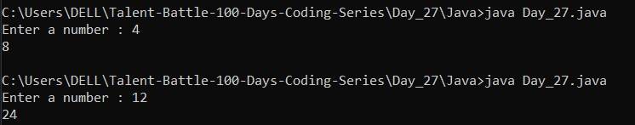**Output:**